Supplementary material

Supplementary Table 1. The baseline characteristics of patients with cervical cancer in the TCGA and GSE data cohorts.

|  |  |  |  |  |  |
| --- | --- | --- | --- | --- | --- |
| Covariates | | Total, n (%) | Data sets, n (%) | | *p* value |
| TCGA cohort | GSE cohort |
| Age (yr) | | | | | |
|  | ≤65 | 355 (86.4) | 275 (89.0) | 80 (78.4) | 0.026 |
| >65 | 56 (13.6) | 34 (11.0) | 22 (21.6) |
| FIGO stage | | | | | |
|  | I | 220 (53.5) | 167 (54.0) | 53 (52.0) | 0.073 |
| II | 89 (21.7) | 71 (23.0) | 18 (17.6) |
| III | 76 (18.5) | 49 (15.9) | 27 (26.5) |
| IV | 26 (6.3) | 22 (7.1) | 4 (3.9) |
| Grade | | | | | |
|  | G1 | 28 (7.9) | 21 (6.8) | 7 (14.9) | 0.034 |
| G2 | 165 (46.5) | 138 (44.8) | 27 (57.4) |
| G3 | 132 (37.2) | 121 (39.3) | 11 (23.4) |
| GX | 30 (8.5) | 28 (9.1) | 2 (4.3) |
| Pathology | | | | | |
|  | SCC | 62 (15.1) | 49 (15.9) | 13 (12.7) | 0.648 |
| ACC | 8 (1.9) | 6 (1.9) | 2 (2.0) |
| ASCC | 341 (83.0) | 254 (82.2) | 87 (85.3) |

ACC, adenocarcinoma; SCC, squamous carcinoma; ASCC, adenosquamous carcinoma; FIGO, The International Federation of Gynecology and Obstetrics; TCGA, The Cancer Genome Atlas; GSE, Gene Expression Omnibus.

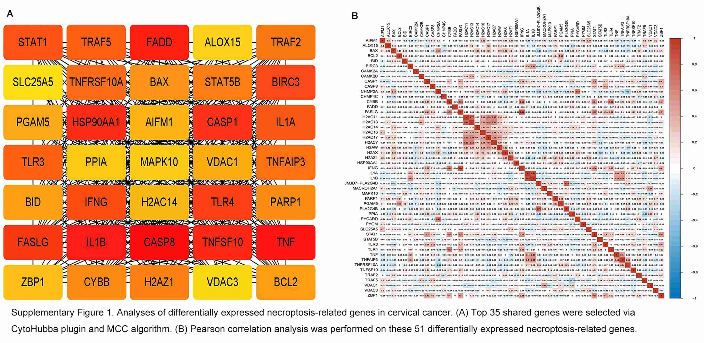

Supplementary Fig. 1. Analyses of differentially expressed necroptosis-related genes in cervical cancer. (A) Top 35 shared genes were selected *via* Cytohubba plugin and MCC algorithm. (B) Pearson correlation analysis was performed on these 51 differentially expressed necroptosis-related genes.

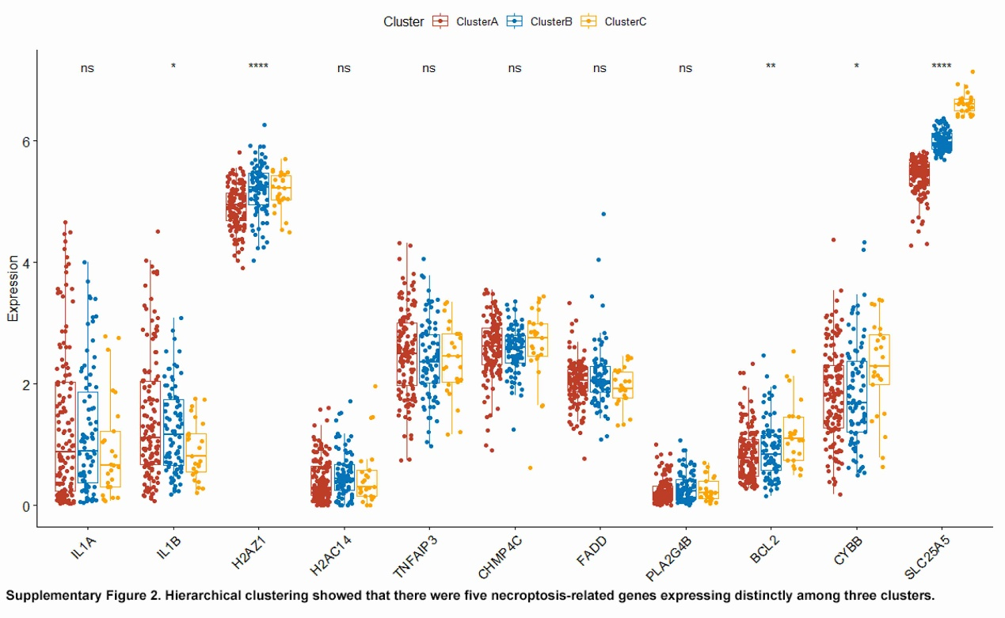

Supplementary Fig. 2. Hierarchical clustering showed that there were five necroptosis-related genes expressing distinctly among three clusters.

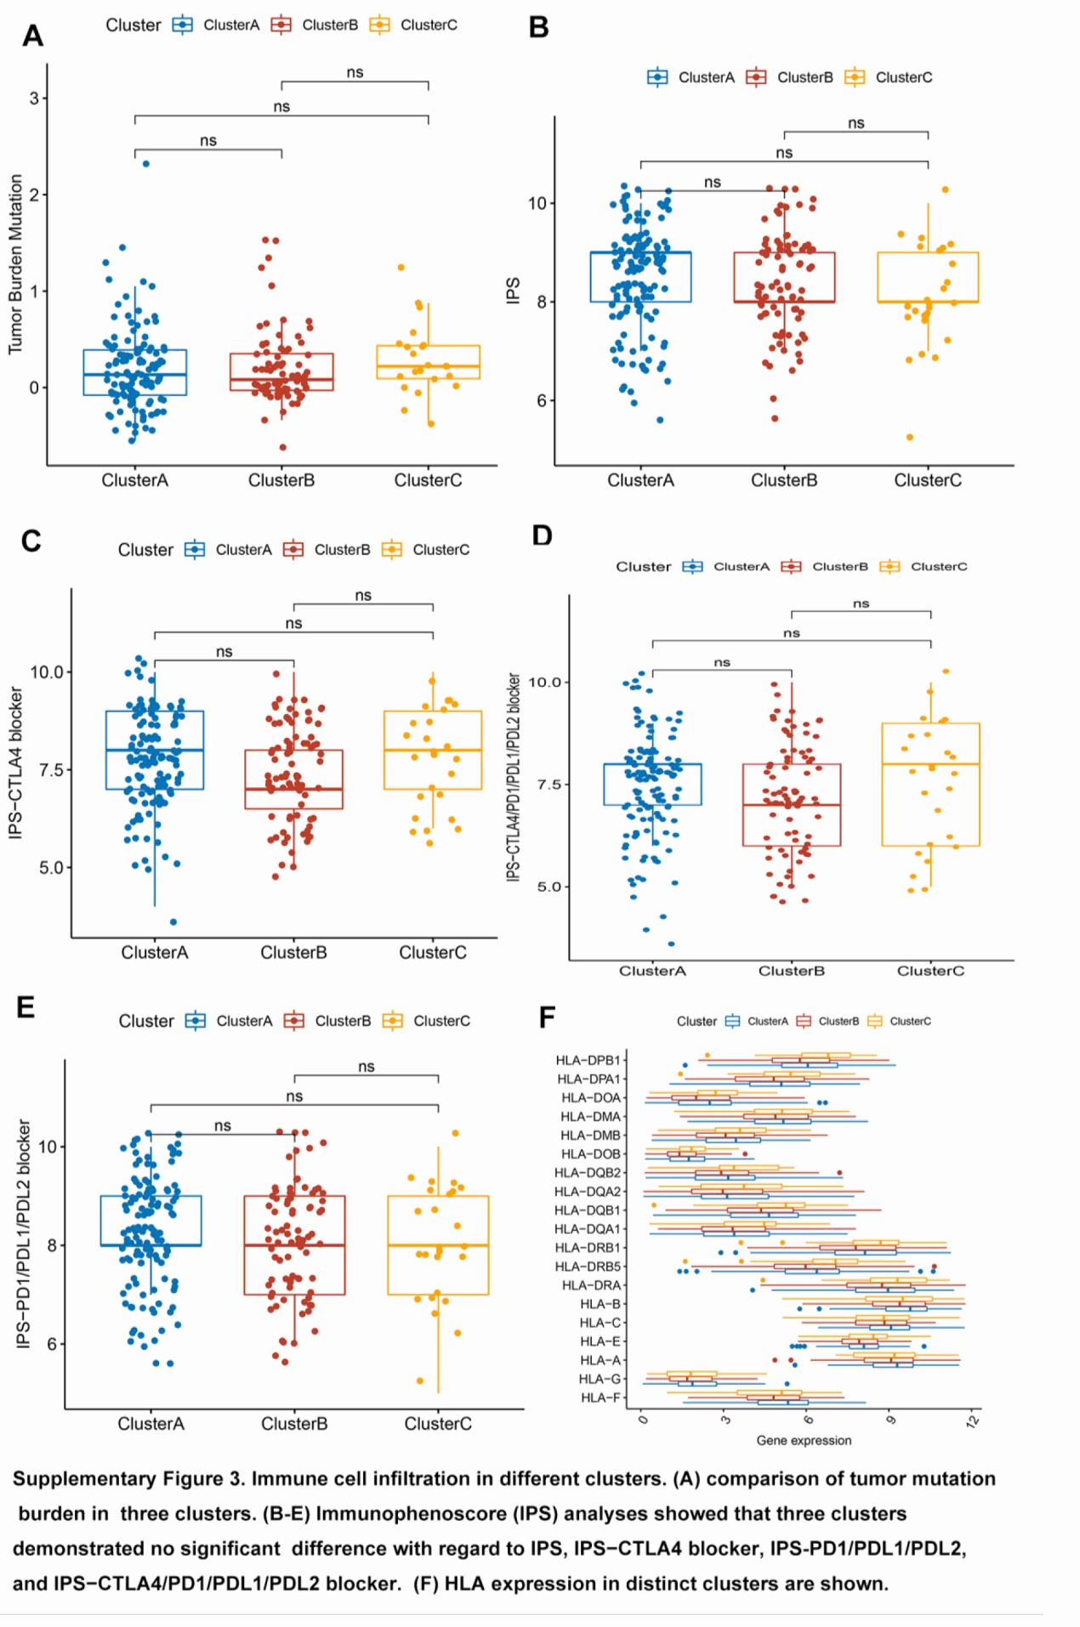

Supplementary Fig. 3. Immune cell infiltration in different clusters. (A) comparison of tumor mutation burden in three clusters. (B–E) Immunophenoscore (IPS) analyses showed that three clustersdemonstrated no significant difference with regard to IPS, IPS-CTLA4 blocker, IPS-PD1/PDL1/PDL2 and IPS-CTLA4/PD1/PDL1/PDL2 blocker. (F) HLA expression in distinct clusters is shown.

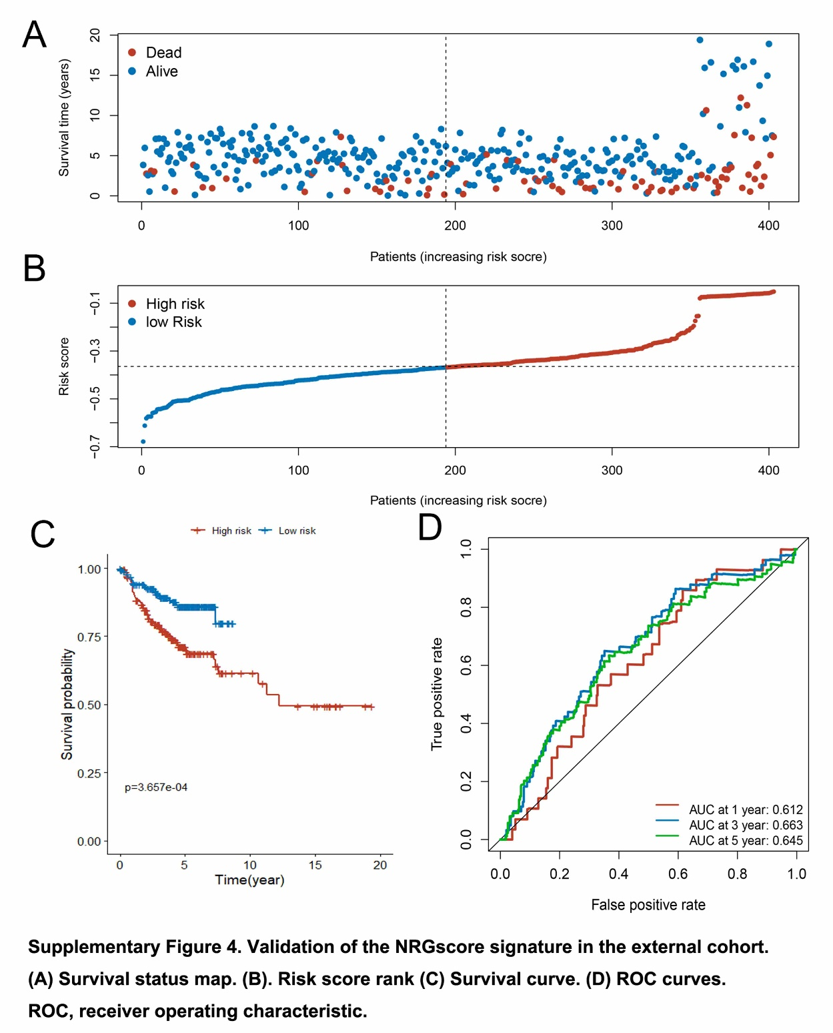

Supplementary Fig. 4. Validation of the NRGscore signature in the external cohort. (A) Survival status map. (B) Risk score rank. (C) Survival curve. (D) ROC curvesROC, receiver operating characteristic.

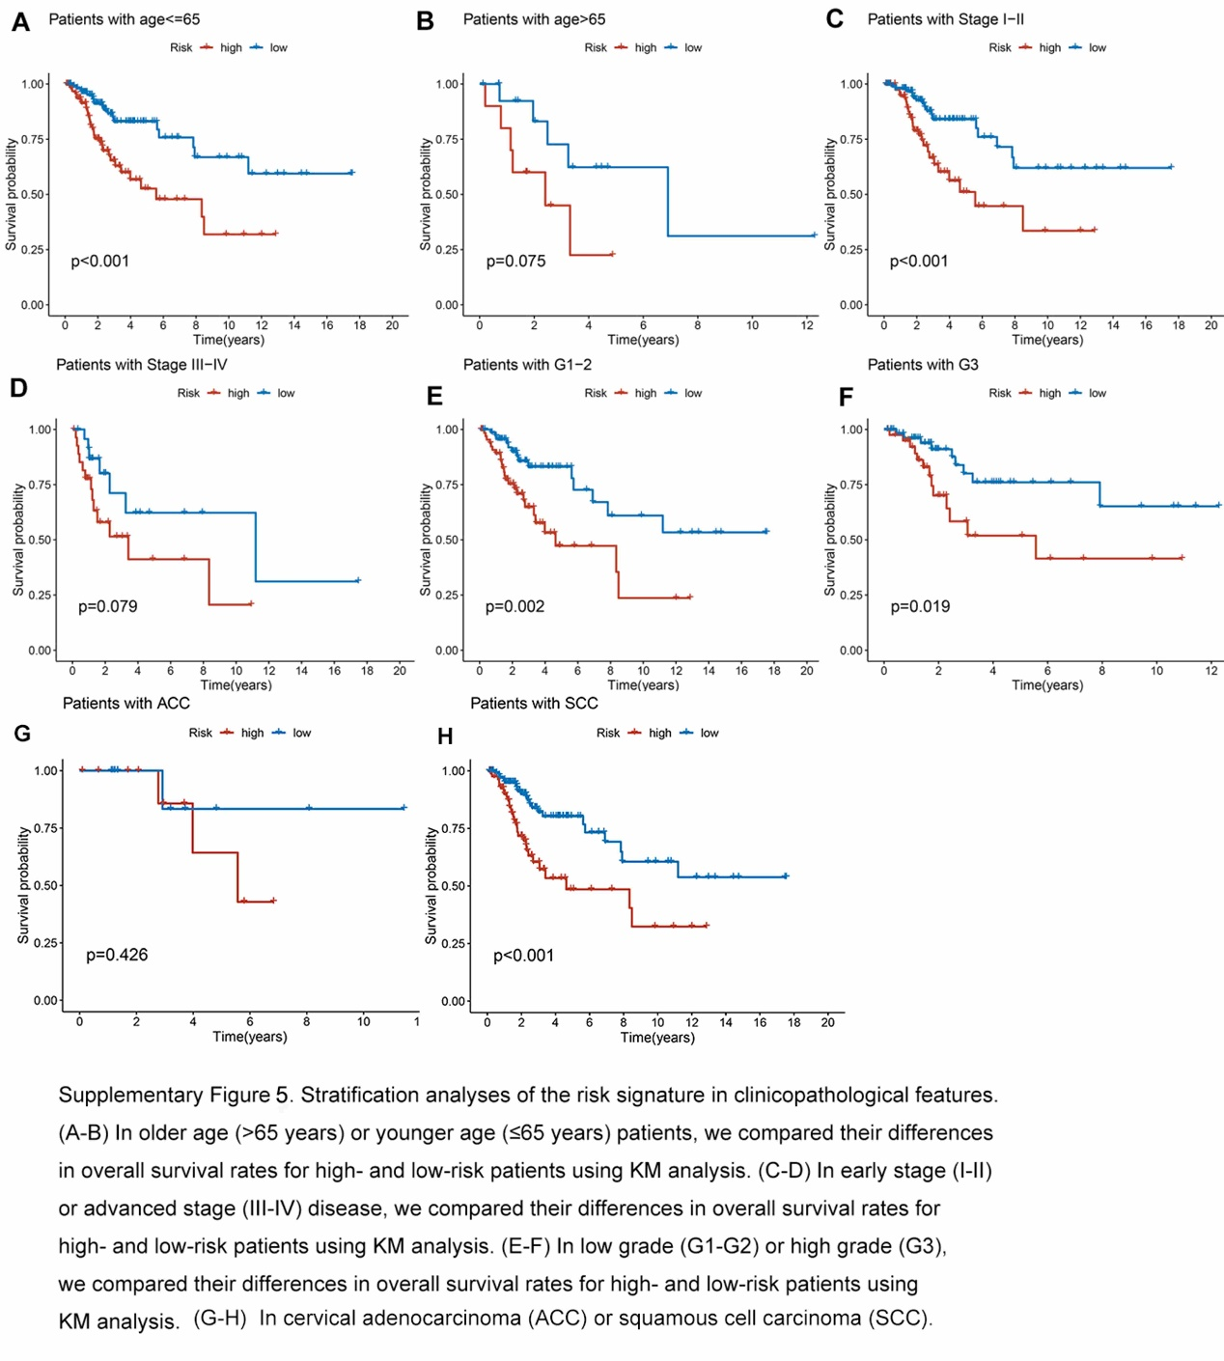

Supplementary Fig. 5. Stratification analyses of the risk signature in clinicopathological features. (A,B) In older age (>65 years) or younger age (≤65 years) patients, we compared their differencesin overall survival rates for high- and low-risk patients using KM analysis. (C,D) In early stage (I–II) or advanced stage (III–IV) disease, we compared their differences in overall survival rates for high- and low-risk patients using KM analysis. (E,F) In low grade (G1–G2) or high grade (G3), we compared their differences in overall survival rates for high- and low-risk patients using KM analysis. (G,H) In cervical adenocarcinoma (ACC) or squamous cell carcinoma (SCC).

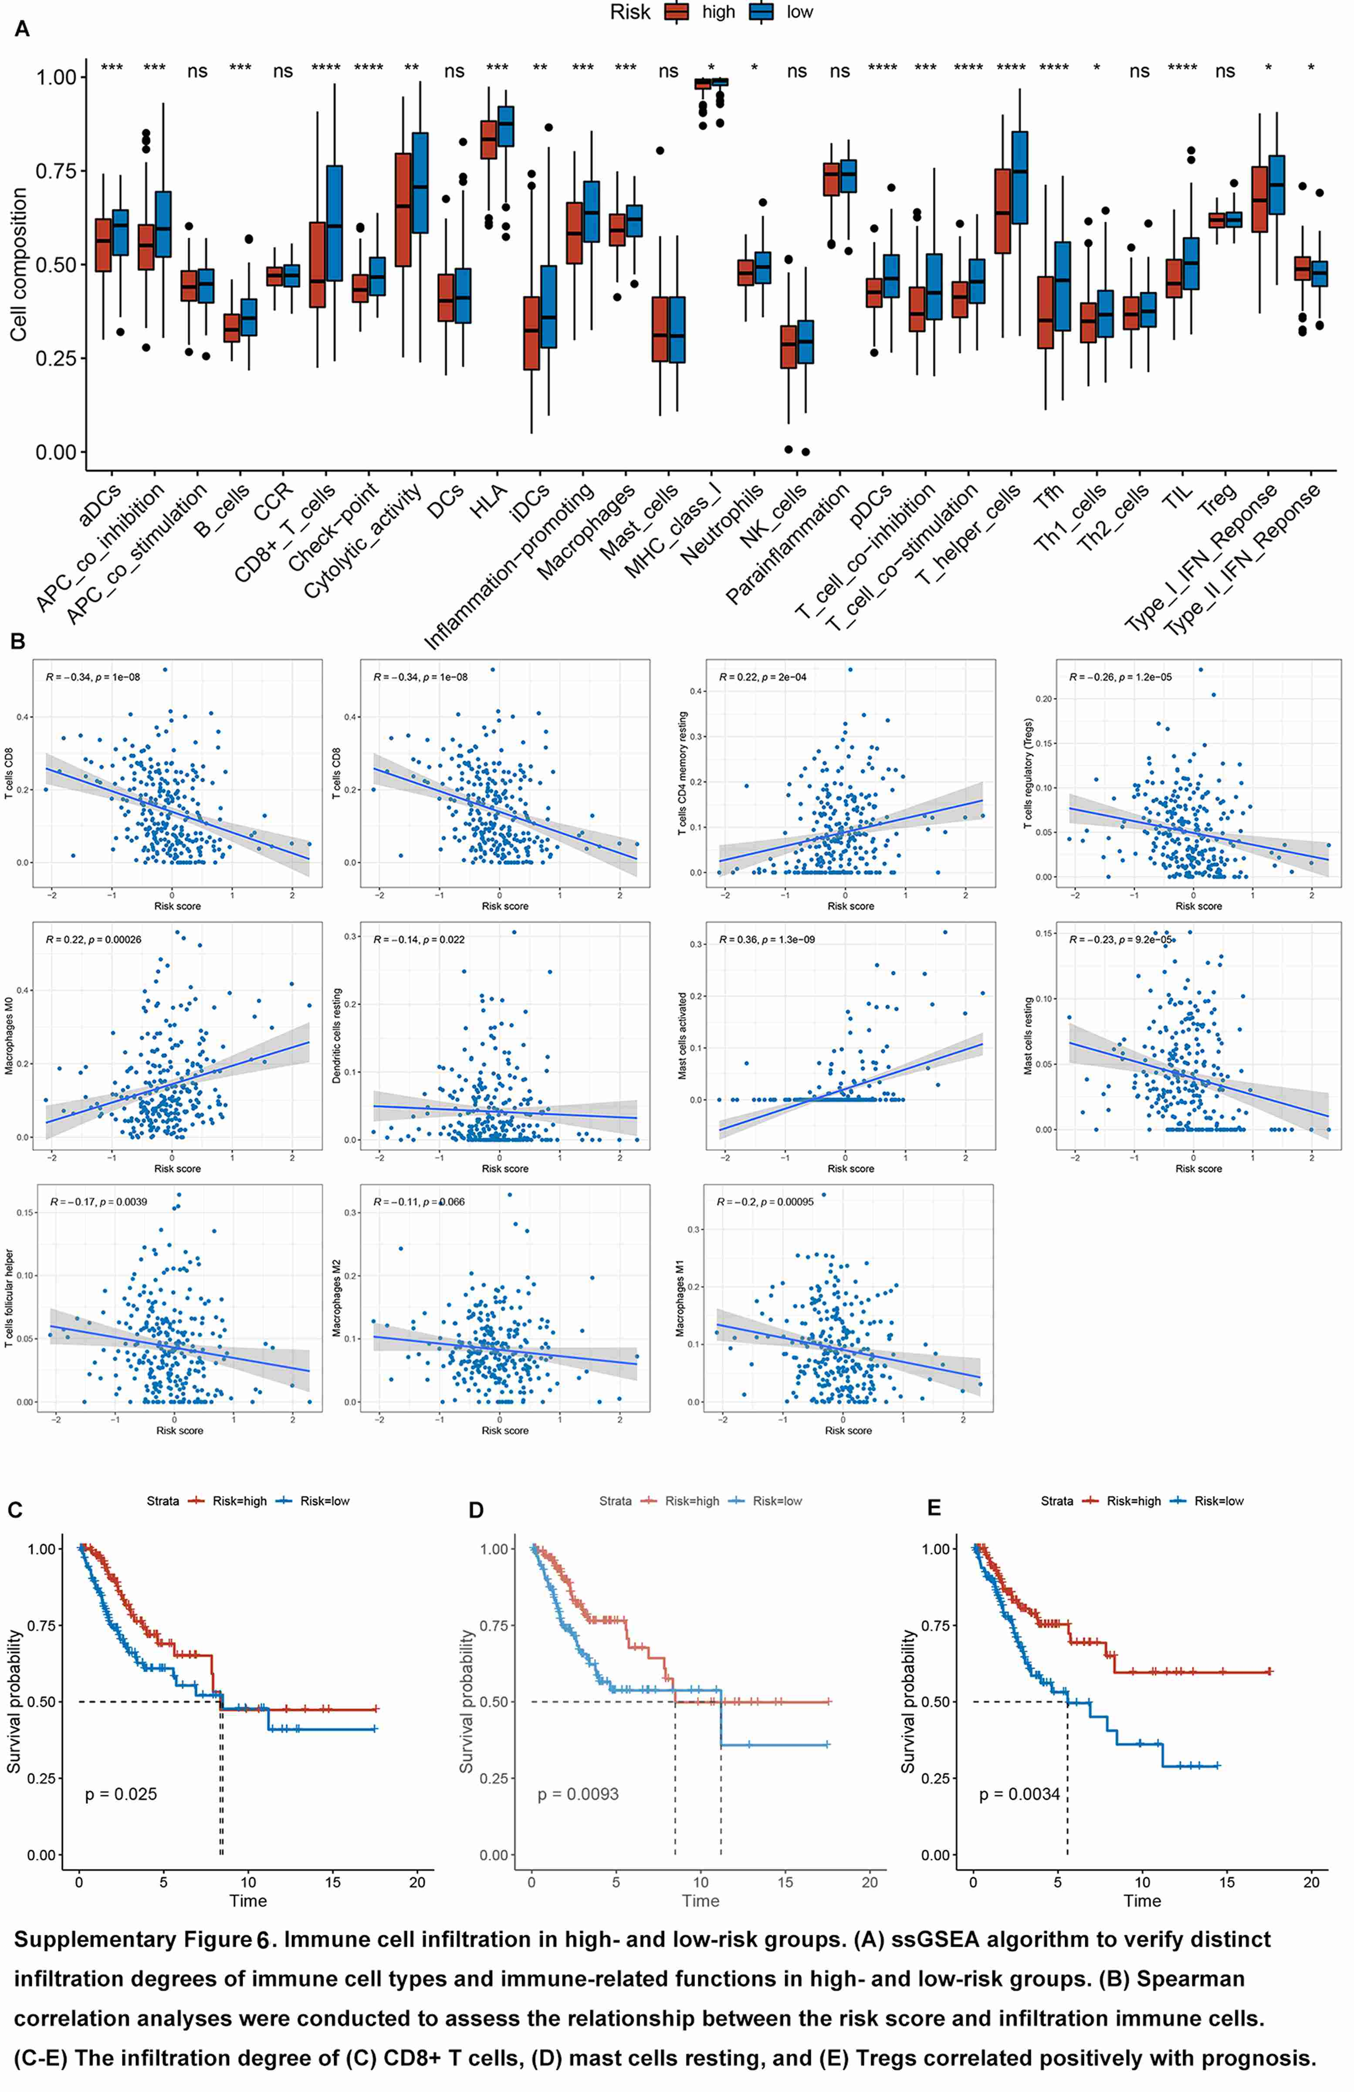

Supplementary Fig. 6. Immune cell infiltration in high- and low-risk groups. (A) ssGSEA algorithm to verify distinct infiltration degrees of immune cell types and immune-related functions in high-and low-risk groups. (B) Spearman correlation analyses were conducted to assess the relationship between the risk score and infiltration immune cells. (C–E) The infiltration degree of (C) CD8+ T cells, (D) mast cells resting, and (E) Tregs correlated positively with prognosis.

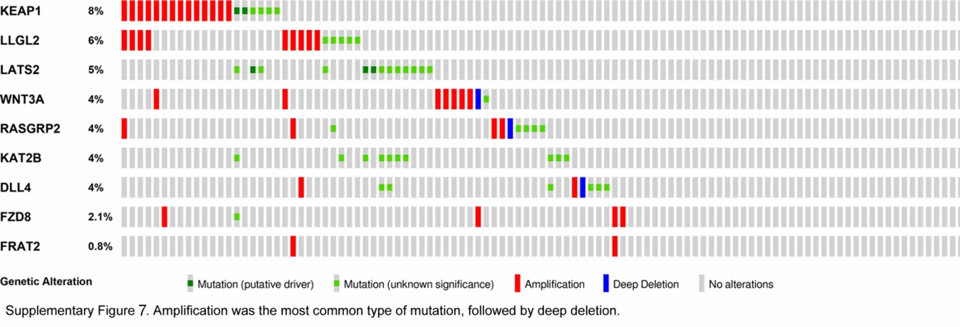

Supplementary Fig. 7. Amplification was the most common type of mutation, followed by deep deletion.

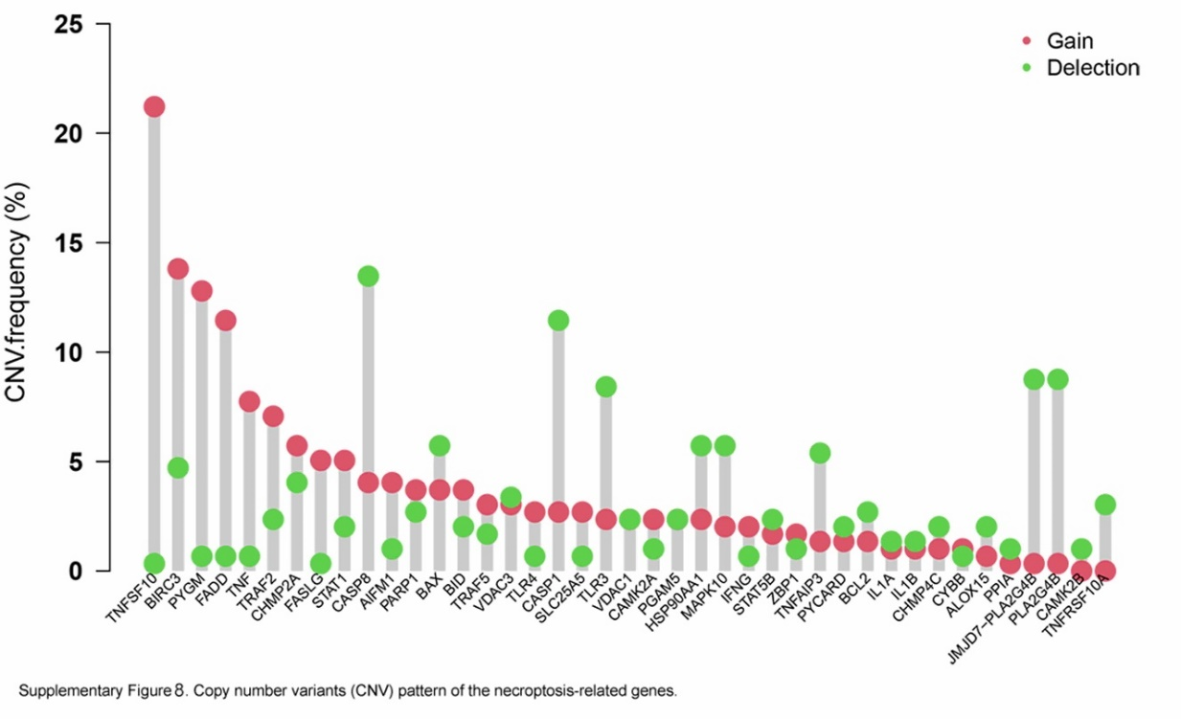

Supplementary Fig. 8. Copy number variants (CNVs) pattern of the necroptosis-related genes.

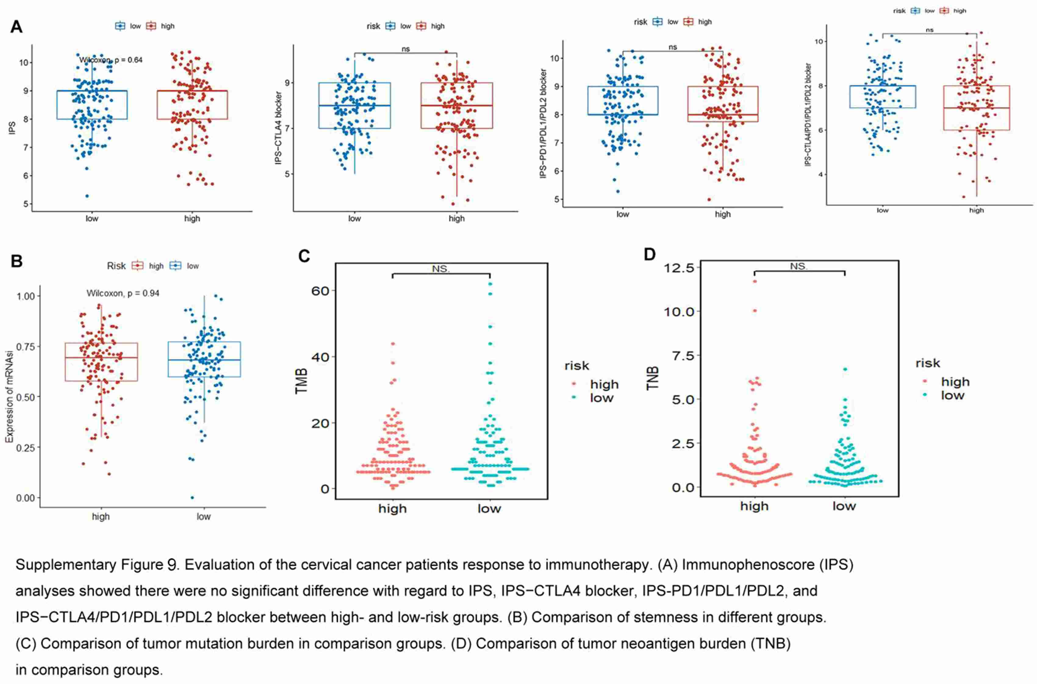

Supplementary Fig. 9. Evaluation of the cervical cancer patients response to immunotherapy. (A) Immunophenoscore (IPS) analyses showed there were no significant difference with regard to IPS, IPS-CTLA4 blocker, IPS-PD1/PDL1/PDL2, and IPS-CTLA4/PDL/PDL1/PDL2 blocker between high-and low-risk groups. (B) Comparison of stemness in different groups. (C) Comparison of tumor mutation burden in comparison groups. (D) Comparison of tumor neoantigen burden (TNB) in companson groups.